**Research blurb:**

Dr. Verbridge is primarily interested in cell-tissue interactions that occur during tumor progression and therapy response. He is broadly interested in leveraging 3D engineered models of diseased tissue in order to dissect these various interactions, with the goal of ultimately improving cancer therapies. Specific projects in the Verbridge lab involve synthesis of new biomimetic tissue scaffold systems, and the use of these platforms to understand the role of matrix degradation components, low-grade inflammation, as well as microbiome residents on cancer dynamics. These projects are in collaboration with researchers in the Chemistry and Biology departments at Virginia Tech. We additionally work on other highly clinically motivated topics in collaboration with other CTE members, focusing on malignant brain tumors. We specifically collaborate with Dr. Rafael Davalos on leveraging tissue-engineered brain models in combination with mathematical tissue simulations to better understand the response of various cell types to electric field-based therapies such as Irreversible Electroporation. The goal of this research is to make these treatments more targeted in nature, so that only highly malignant cell types are destroyed. This work is also in collaboration with clinicians and researchers in the Virginia-Maryland College of Veterinary Medicine, the Virginia Tech Carilion Research Institute, and the Wake Forest Comprehensive Cancer Center.

**Students currently supervised:**

Brittany Balhouse

Megan Cox

Jill Ivey

**Postdoc currently supervised:**

Akanksha Kanitkar

**Website:**

[www.verbridgelab.org](http://www.verbridgelab.org)

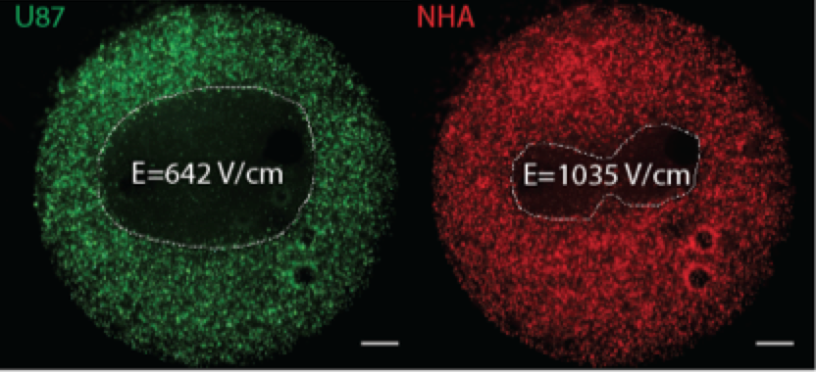**Figure 1**. Dark regions in 3D hydrogels represent kill zones for tumor cells (in green) and normal astrocytes (in red) in co-culture after exposure to 0.5 us HFIRE pulses. The tumor lesion is significantly larger than the astrocyte lesion, defining a zone of tumor cell-specific cell death in this 3D co-culture. Scale bars: 1 mm.

**Current project:**

In collaboration with Dr. Davalos, we are currently working to understand cell-specific responses to High Frequency Irreversible Electroporation (HFIRE) pulses, in order to ultimately translate this technique for the targeted ablation of malignant cells in glioma. PhD students primarily working on this project are Jill Ivey in the Verbridge lab, and Eduardo Latouche in the Davalos lab, who have thus far demonstrated tumor cell-specific targeting in 3D tissue-engineered tumor co-culture models (Fig. 1, adapted from Ivey, Latouche et. al., Scientific Reports, Accepted). This project is ongoing, and current efforts are to understand specific death mechanisms resulting from HFIRE and the potential for enhancing these death responses, as well as the response of primary patient-derived cell types, including glioma stem cells (GSCs).